**Lesson 5 Demo 1**

**Azure Alerts**



Steps to be followed:

1. Going to the Azure portal
2. Searching for and selecting Monitor
3. Creating an Azure alert

**Step 1: Going to the Azure portal**

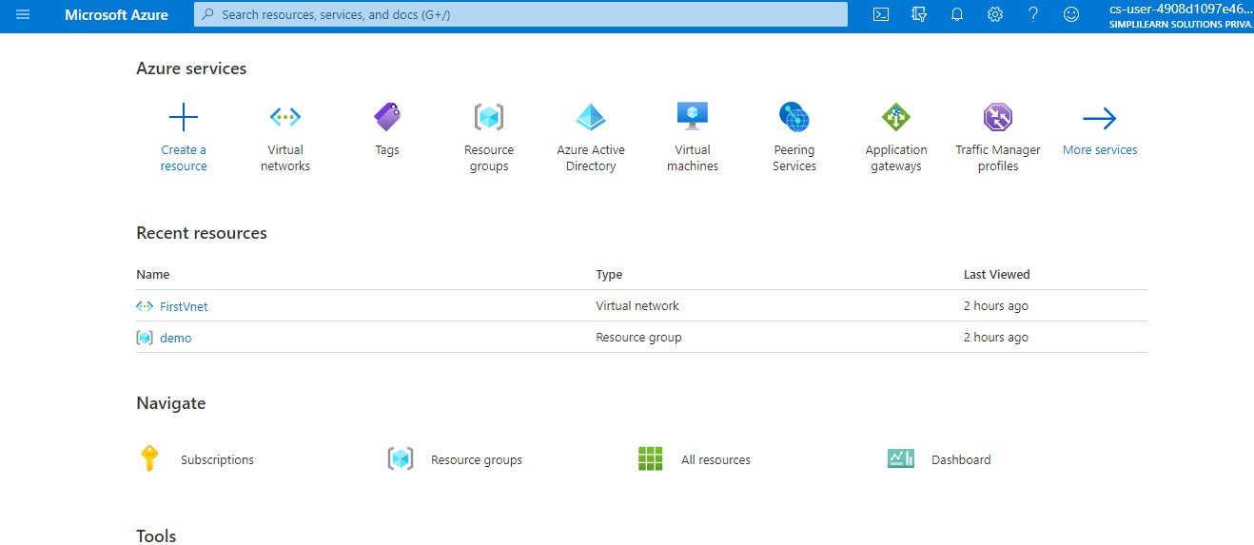

**Step 2: Searching for and select Monitor**

The Monitor blade consolidates all your monitoring settings and data in one view

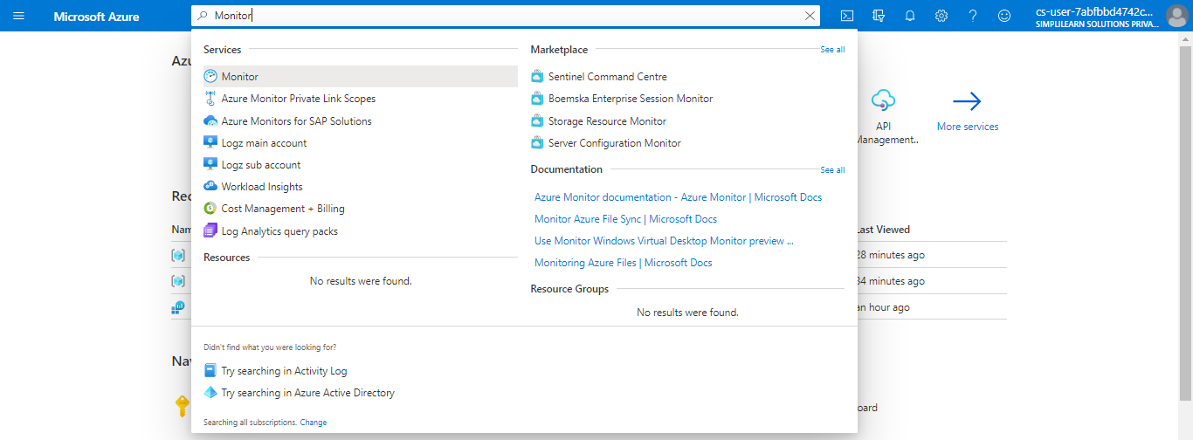

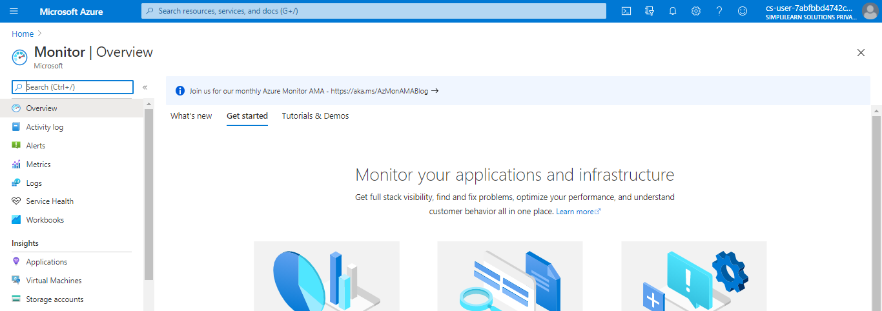

**Step 3: Creating an Azure alerts**

3.1 Click on **Alerts** and click **+ New alert** **rule**

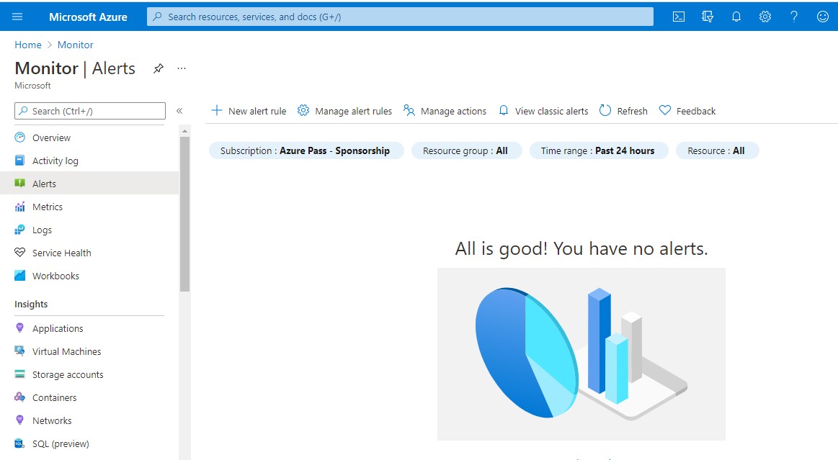

3.2 Click **Select resource**, in the context pane that loads, select a target resource that you

want to be alert. Use Subscription and Resource type drop-downs to find the resource

you want to monitor. You can also use the search bar to find your resource.

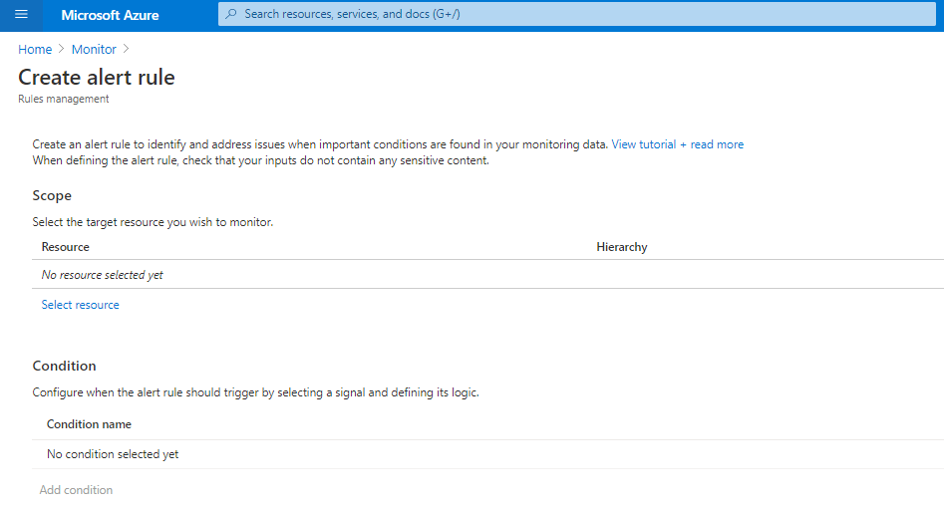

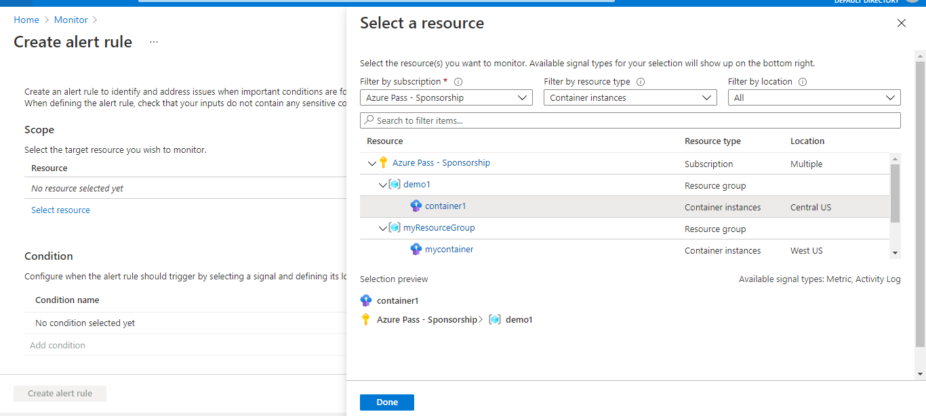

3.3 If the selected resource has metrics you can create alerts on, **Available signals** on the

bottom right will include metric. Once you select a target resource, click on **Add condition**

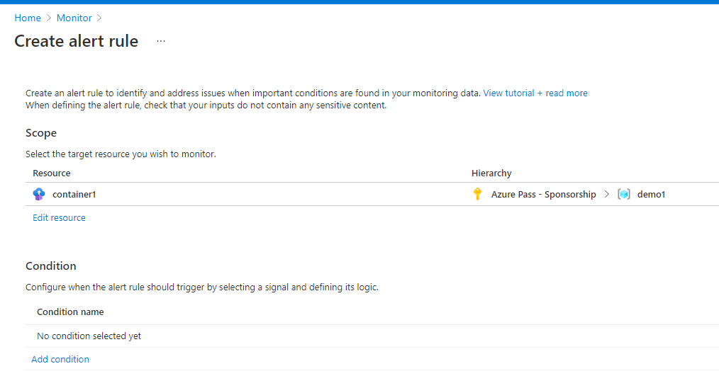

3.4 You will see a list of signals supported for the resource; select the metric you want to create an alert on

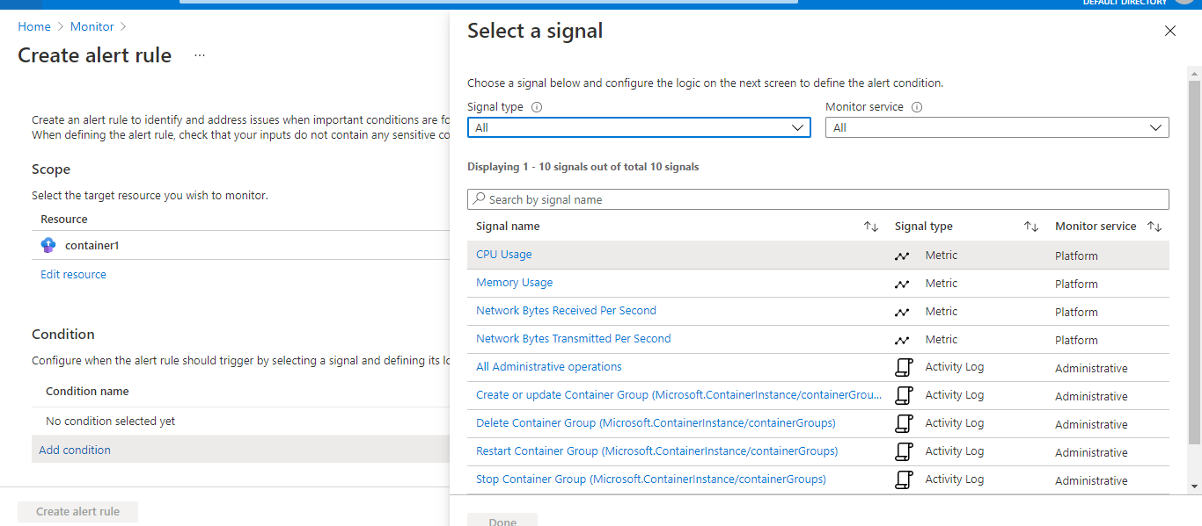

3.5 You will see a chart for the metric for the last six hours. Use the **Chart period** dropdown to select to see longer history for the metric

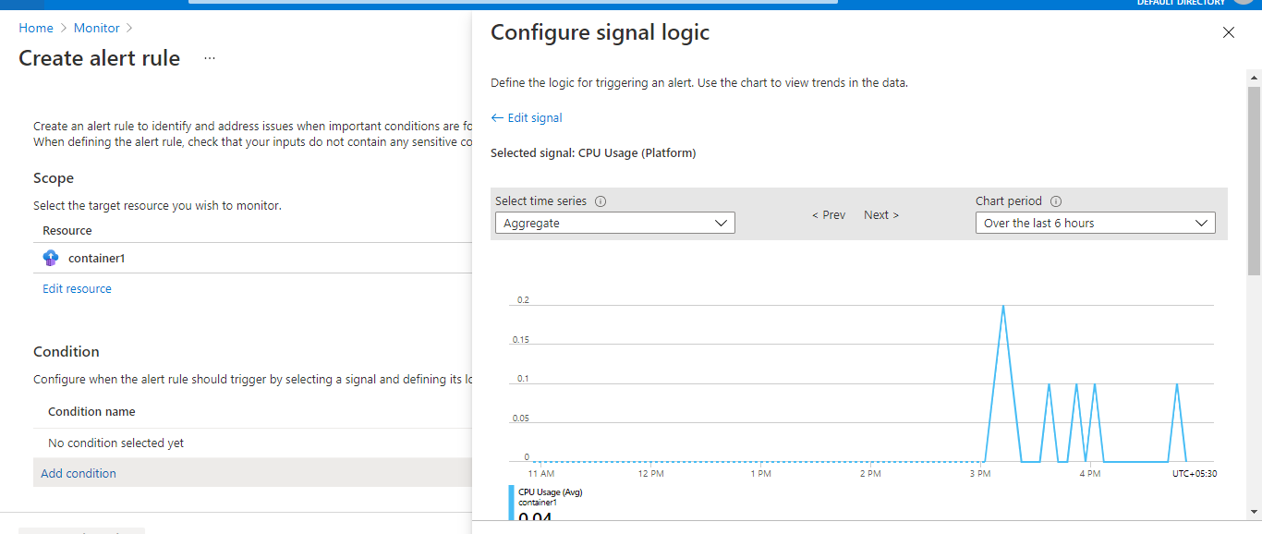 

3.6 Select the **Threshold type**, **Operator**, and **Aggregation type**. This will determine the logic that the metric alert rule will evaluate and click on **Done**.

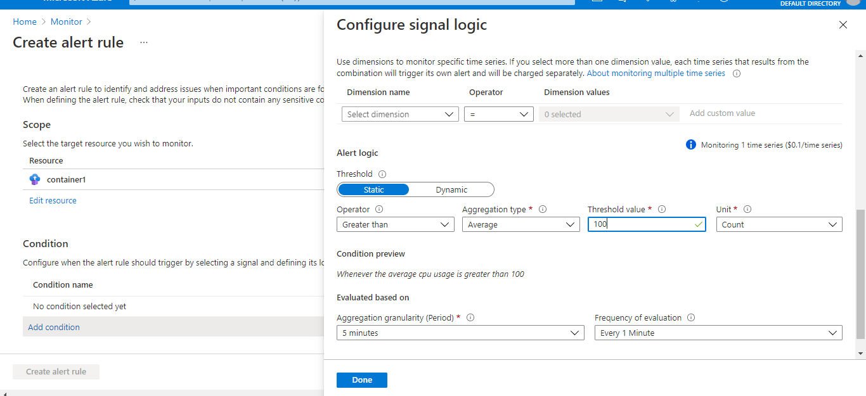

3.7 Fill in Alert details like Alert rule name, Description, and Severity

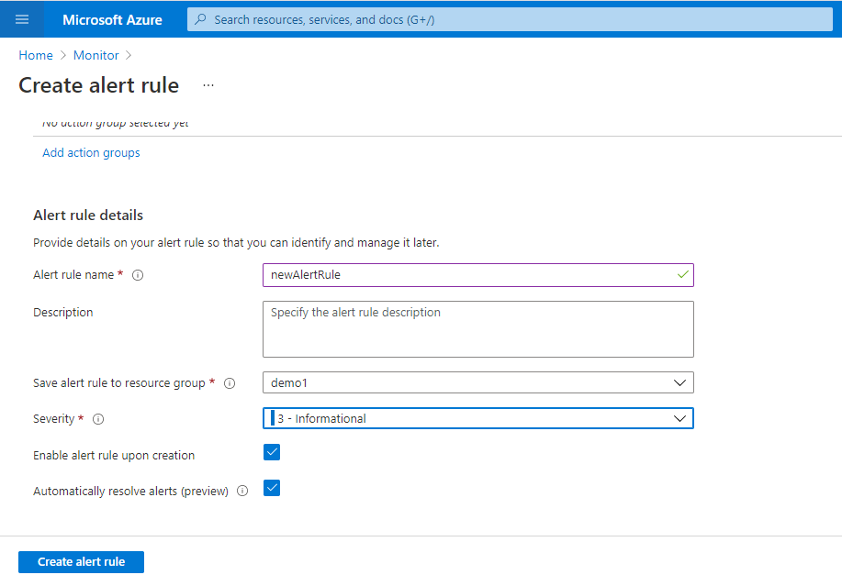

3.8 Add an action group to the alert either by selecting an existing action group or creating a new action group

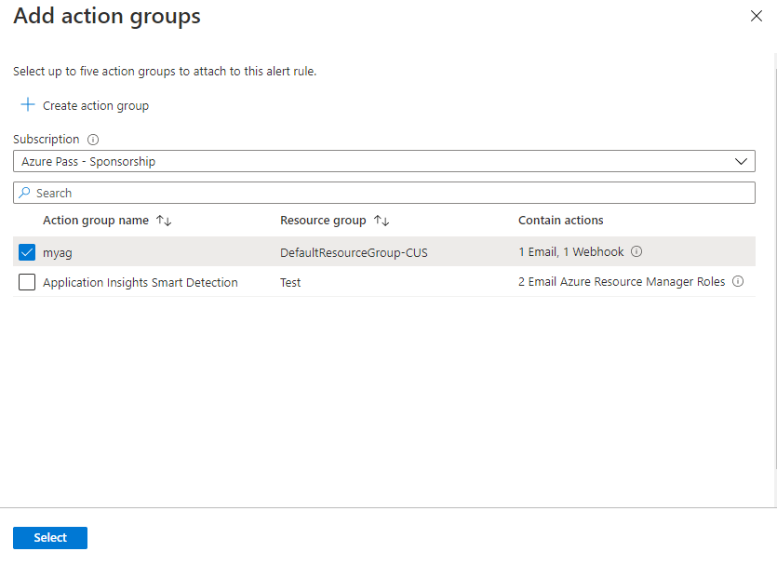

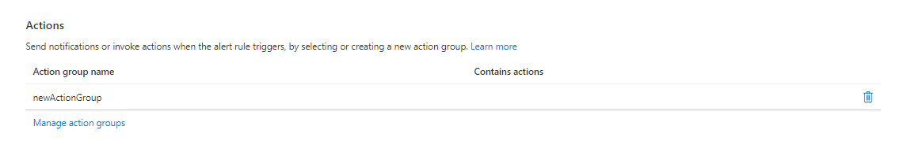

3.9 Click on **Create alert rule**

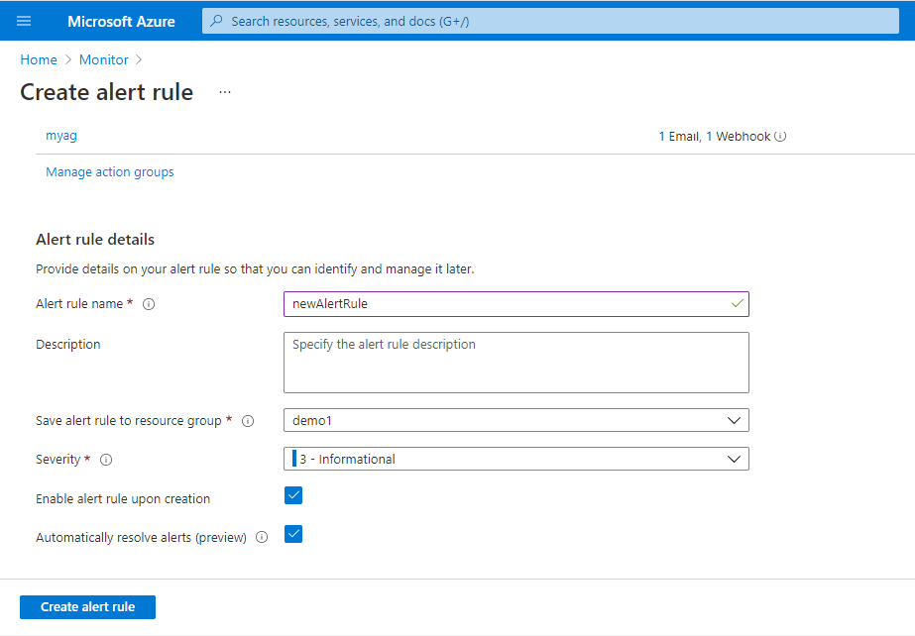

New alert rule will get created

